Course Code:21AI44 | Date:
Sem: IV | Duration: 90 Minutes
CIE-II
Data Base Management Systems
Answer all Questions
SL. No |  | Questions | M | BT | CO
1 | a) | Define data, Information, Database, Database Management System, Database System  - Data, we mean known facts that can be recorded and that have implicit meaning  - DBMS - is a general-purpose software system that facilitates the processes of defining, constructing, manipulating, and sharing databases among various users and applications.  - Processed data is information | 10 | 2 | 1
2 | a) | 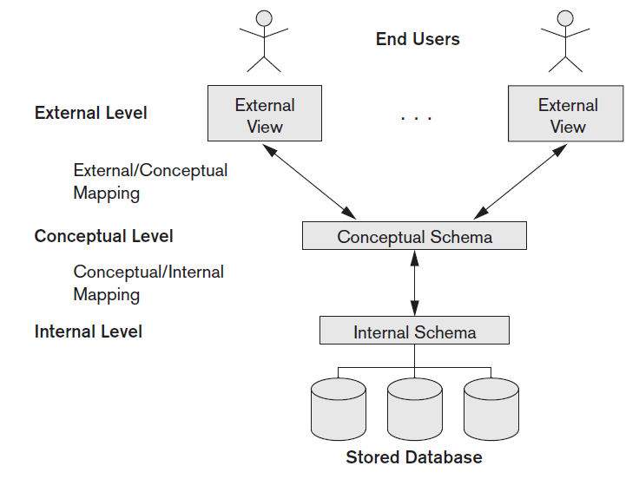  The internal level has an internal schema, which describes the physical storage structure of the database. The internal schema uses a physical data model and describes the complete details of data storage and access paths for the database.  2. The conceptual level has a conceptual schema, which describes the structure of the whole database for a community of users. The conceptual schema hides the details of physical storage structures and concentrates on describing entities, data types, relationships, user operations, and constraints. Usually, a representational data model is used to describe the conceptual schema when a database system is implemented. This implementation conceptual schema is often based on a conceptual schema design in a high-level data model.  3. The external or view level includes a number of external schemas or user views. Each external schema describes the part of the database that a particular user group is interested in and hides the rest of the database from that user group. As in the previous level, each external schema is typically implemented using a representational data model, possibly based on an external schema design in a high-level conceptual data model. | 06 | 3 | 2
 | b) | Characterize the difference between Physical and Logical data independence with examples  - Logical data independence is the capacity to change the conceptual schema without having to change external schemas or application programs  - We may change the conceptual schema to expand the database (by adding a record type or data item), to change constraints, or to reduce the database (by removing a record type or data item).  - In the last case, external schemas that refer only to the remaining data should not be affected  - Only the view definition and the mappings need to be changed in a DBMS that supports logical data independence.  - After the conceptual schema undergoes a logical reorganization, application programs that reference the external schema constructs must work as before.  - Changes to constraints can be applied to the conceptual schema without affecting the external schemas or application programs.  Physical data independence is the capacity to change the internal schema without having to change the conceptual schema.  - Hence, the external schemas need not be changed as well. Changes to the internal schema may be needed because some physical files were reorganized—for example, by creating additional access structures—to improve the performance of retrieval or update.  - If the same data as before remains in the database, we should not have to change the conceptual schema |  | 2 | 1
3 | a) | Explain the Characteristics of Database Approach  - Self-describing nature of a database system  - Insulation between programs and data, and data abstraction  - Support of multiple views of the data  - Sharing of data and multiuser transaction processing  Explanation these characteristics | 05 | 1 | 1
 | b) | List the roles and responsibilities of a Database Administrator  - Database Administrators - In any organization where many people use the same resources, there is a need for a chief administrator to oversee and manage these resources.  - In a database environment, the primary resource is the database itself, and the secondary resource is the DBMS and related software.  - Administering these resources is the responsibility of the database administrator (DBA).  - The DBA is responsible for authorizing access to the database, coordinating and monitoring its use, and acquiring software and hardware resources as needed.  - The DBA is accountable for problems such as security breaches and poor system response time.  - In large organizations, the DBA is assisted by a staff that carries out these functions. | 05 | 1 | 1
4 | a) | Discuss the characteristics of NoSQL?  - Schemaless data representation: Almost all NoSQL implementations offer schema less data representation. This means that you don’t have to think too far ahead to define a structure and you can continue to evolve over time— including adding new fields or even nesting the data, for example, in case of JSON representation.  - Development time : Doesn’t have to deal with complex SQL queries.  - Speed: Even with the small amount of data that you have, if you can deliver in milliseconds rather than hundreds of seconds  - Plan ahead for scalability: Application can be quite elastic—it can handle sudden spikes of load. |  | 1 | 1
 | b) | Explain the storage details of Document storage type and gives its advantages?  - Also referred to as document-oriented database, a document store allows the inserting, retrieving, and manipulating of semi-structured data.  - Most of the databases available under this category use XML, JSON, BSON, or YAML, with data access typically over HTTP protocol using RESTful API or over Apache Thrift protocol for cross-language interoperability.  - Compared to RDBMS, the documents themselves act as records (or rows), however, it is semi-structured as compared to rigid RDBMS.  - For example, two records may have completely different set of fields or columns.  - The records may or may not adhere to a specific schema (like the table definitions in RDBMS).  - For that matter, the database may not support a schema or validating a document against the schema at all.  - Even though the documents do not follow a strict schema, indexes can be created and queried.  Advantages:  - The most prominent advantage, as evident in the preceding examples, is that content is schema less  - This is very useful in web-based applications where there is a need for storing different types of content that may evolve over time.  - For example, for a grocery store, information about the users, inventory and orders can be stored as simple JSON or XML documents.  - Based on the implementation, it may or may not be possible to retrieve or update a record partially.  - Because, now, there is no concept of tables—which is essentially nothing more than a schema definition—one can query across the records, irrespective of the underlying content or schema or in other words, the query is directly against the entire database. | 05 | 2 | 1
5 |  | Consider the database “My Database” and collection Book with the fields Book_Id, Book Title, Book Author, Likes. Write the query to do the following? Explain the function/method used in the query?  - Insert books into the collection  - List the documents with tittle “NoSQL”  - List all the documents whose likes are greater than 500  - Delete all the documents who likes are less than 10  - Update the Book Author for the Book Title “ DBMS”  Each query 5*2 = 10 marks  - db.book.insert({Book_id : 01  Book title : “DBMS”  Book Author : “Navathe”  Likes : 10} )  - db.book.find({title: “NOSQL”})  - db.book.find({“Likes” :{$gt:500}}).pretty()  - db.book.remove({“Likes”:{$lt:10}})  - db.book.updateMany({Book Title : “DBMS”},  {$set:{Book Author : Raghu}} | 10 | 3 | 3

Course Outcome
CO1 | Understand and Apply Database Management Systems concepts to solve the given problem
CO2 | Design solutions with societal and environmental concerns using modern tools to solve problems in Database Design domain
CO3 | Analyze and develop Database Applications using SQL and NoSQL features by engaging in lifelong learning for emerging technology
CO4 | Exhibit effective communication and engage in continuing professional development through experiential learning
CO5 | Demonstrate skills like investigation, effective communication, working in team/Individual practices by implementing Database Design concepts and applications
M-Marks, BT-Blooms Taxonomy Levels, CO-Course Outcomes
Marks Distribution | Particulars | CO1 | CO2 | CO3 | CO4 | L1 | L2 | L3 | L4 | L5 | L6
 | Max Marks | 10 | 20 | 20 | -- | -- | 10 | 20 | 20 | -- | --

